**How does PPP interface with different network layer protocols?**

by specifying the protocol during link establishment through LCP  
by encoding the information field in the PPP frame  
**by using separate NCPs\***  
by negotiating with the network layer handler

**Which field marks the beginning and end of an HDLC frame?**

FCS  
**Flag\***  
Control  
Data

**Which three statements are true about PPP? (Choose three.)**

**PPP can use synchronous and asynchronous circuits.\***  
PPP carries packets from several network layer protocols in LCPs.  
PPP can only be used between two Cisco devices.  
**PPP uses LCPs to agree on format options such as authentication, compression, and error detection.\***  
**PPP uses LCPs to establish, configure, and test the data link connection.\***

**Which three statements are true about PPP? (Choose three.)**

**PPP can use synchronous and asynchronous circuits.\***  
PPP carries packets from several network layer protocols in LCPs.  
PPP can only be used between two Cisco devices.  
**PPP uses LCPs to agree on format options such as authentication, compression, and error detection.\***  
**PPP uses LCPs to establish, configure, and test the data link connection.\***

**Which three physical layer interfaces support PPP? (Choose three.)**

GigabitEthernet  
**asynchronous serial\***  
**HSSI*  
synchronous serial\***  
POTS  
FastEthernet

**Which three are types of LCP frames used with PPP? (Choose three.)**

link-negotiation frames  
link-acknowledgment frames  
**link-maintenance frames\***  
**link-termination frames\***  
**link-establishment frames\***  
link-control frames

**Which protocol will terminate the PPP link after the exchange of data is complete?**

IPCP  
**LCP\***  
IPXCP  
NCP

**Which PPP option can detect links that are in a looped-back condition?**

**Magic Number\***  
Callback  
MRU  
ACCM

**A network administrator is evaluating authentication protocols for a PPP link. Which three factors might lead to the selection of CHAP over PAP as the authentication protocol? (Choose three.)**

**uses an unpredictable variable challenge value to prevent playback attacks\***  
**uses a three-way authentication periodically during the session to reconfirm identities\***  
**transmits login information in encrypted format\***  
control by the remote host of the frequency and timing of login events  
establishes identities with a two-way handshake  
makes authorized network administrator intervention a requirement to establish each session

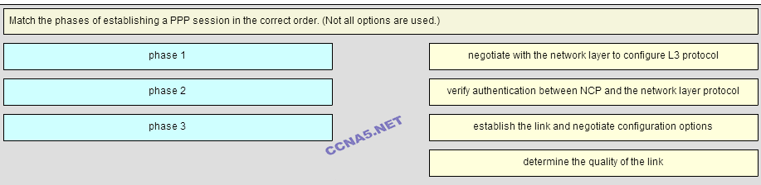

**Place the options in the following order:**   
**Phase 3**   
**– not scored –**   
**Phase 1**   
**Phase 2**

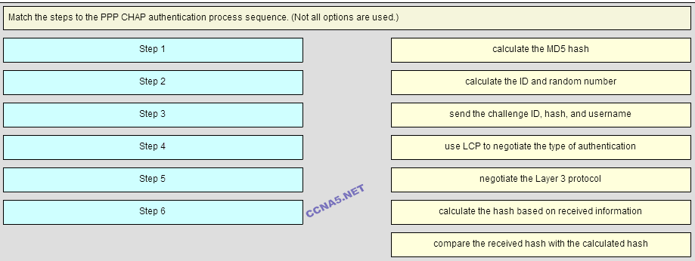

**Place the options in the following order:**   
**Step 3**   
**Step 2**   
**Step 4**   
**Step 1**   
**– not scored –**   
**Step 5**   
**Step 6**